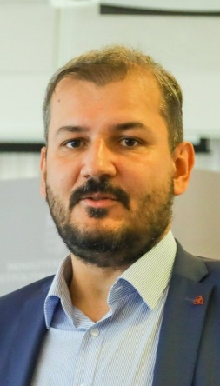
Norbert Tóth
Address:H-1083 Budapest Ludovika sq. 1.
Email: toth.norbert@uni-nke.hu
Phone: +36 (1) 432-9000/20-816
Place and Date of Birth: Nagykanizsa, 1980
Nationality: Hungarian

PROFESSIONAL EXPERIENCE
2020- | Head of Department, Department of International Law, Faculty of Public Governance and International Studies, University of Public Service
2016– | Associate Professor, Department of International Law, Faculty of Public Governance and International Studies, University of Public Service
2015–2016 | Vice Dean for Education, Faculty of International and European Studies, University of Public Service
2011-2016 Senior Lecturer, Department of International Law, Faculty of International and European Studies; Institute for International Studies, University of Public Service
2008-2011 Assistant Professor, Department of International and European Law, Faculty of Public Administration, University of Public Service; Corvinus University of Budapest
2012 Head of Department, Department of International Law, Institute for International Studies, University of Public Service
2012 Head of Department, Department for International Affairs, Office of the Commissioner for Fundamental Rights
2011-2012 Head of Department, Secretariat of the Deputy State Secretary for European Affairs, Ministry of Public Administration and Justice
2007-2010 Researcher, Institute of Studying Minorities, Hungarian Academy of Sciences
2004-2007 PhD student, lecturer Faculty of Law, University of Pécs
2016 Lecturer, Institute for International and Regional Studies, University of Szeged
2012-2015 Department of European Studies, Institute for International Studies and Political Science, Faculty of Social Sciences, ELTE

EDUCATION
2010 | Expert of equal treatment and minority affairs, Corvinus University of Budapest
2010 | MA in Political Science, Faculty of Humanities, University of Pécs
2004 | Master of Laws, Faculty of Law, University of Pécs

STUDIES AND DEGREES
2013 | PhD in Law, University of Pécs

OTHER ACADEMIC AND PROFESSIONAL ACTIVITIES
2014- | Member, Subcommittee of Public International Law, Committee of Legal and Political Science, Hungarian Academy of Science
2014-  2019- | Member of the Editorial Board, Pécs Journal of International and European Law  Member of the Editorial Board, População e Sociedade
2008-2012,2017-  2011-  2018- | Member, American Society of International Law  Member, Association for the Study of Nationalities  Member, European Society of International Law  Member, International Law Association, Hungarian Branch
2020- Member, International Association for Artificial Intelligence and Law
2020- Member, Société Québécoise de droit international
2017- Member, Public body, Hungarian Academy of Sciences

LANGUAGE SKILLS
Hungarian | Native
English | C1
French | B2
Spanish B2
Swedish B2
German A2

